## Test Plan Identifier: LOGIN-CLIENT-001

## Introduction

The purpose of this test plan is to describe the approach, scope and test activities for testing the login page and client page of the application.

### 2.1 Purpose

The purpose of this test plan is to ensure that the login page and client page of the application are functioning as expected and meet the specified requirements. The test plan provides a roadmap for the testing activities and outlines the testing approach, the design techniques, and test environment.

### 2.2 Scope

The scope of this test plan includes testing of the login page and client page of the application. The test plan covers functional testing of the features and functionalities of the pages.

### 2.3 Definition

* Login page: The page that allows users to authenticate themselves by entering their credentials.
* Client page: The page that user’s can create, edit, and view clients data.

## Test Items

The test items in this plan include the following pages of the application:

### 3.1 Login Page

* User authentication: Ensure that users can successfully log in to the application using their credentials.
* Error messages: Verify that appropriate error messages are fisplayed when users enter incorrect or incomplete login information.

### 3.2 Client Page

* Data display: Test the functionality of the user dashboard, ensuring that it display the clients data.
* Add clients: Test the add client functionality to ensure users can add new client.
* Edit clients: Test the edit client functionality to ensure users can edit the client data if user have type while create the client.
* View clients: Ensure that users can view the details of the client by clicking the clients data.

## 

## Features to be Tested

This test plan includes the following features to be tested:

### 4.1 Login Page

* Login with invalid credentials: Test that users cannot login without valid credentials.
* Login with valid credentials: Verify that users can log in to the system using their valid credentials.

### 4.2 Client Page

* Create client: Test that users can add new client by click the add client and input the client data.
* Edit client: Test that users can edit the client data by click the client and change the client data.
* View client: Verify that the view client is working perfectly to view client details.

## Features not to be tested

The following features are not included in the scope of this test plan:

### 5.1 Legal Entities

Legal entities process not included in the scope of this test plan as it has already been tested in a separate test plan.

### 5.2 Loyalty

Loyalty process not included in the scope of this test plan as it has already been tested in a separate test plan.

### 5.3 Referral system

Referral system process not included in the scope of this test plan as it has already been tested in a separate test plan.

### 5.4 Stock

Stock process not included in the scope of this test plan as it has already been tested in a separate test plan.

### 5.5 Coupons

Coupons process not included in the scope of this test plan as it has already been tested in a separate test plan.

### 5.6 Notification

Notification process not included in the scope of this test plan as it has already been tested in a separate test plan.

### 5.7 Report

Report process not included in the scope of this test plan as it has already been tested in a separate test plan.

## Approach

The following approach wil be used for testing the login page and client page of the application:

### 6.1 Test Design Techniques

Test cases will be designed using various techniques. The goal is to ensure that all possible scenarios are covered and that the functionality of the login page and client page is thoroughly tested.

### 6.2 Test Environment

The testing environment will consis of a dedicated testing environment that is separate from the production environment. The environment will be set up to simulate real-world usage scenarios and will include a variety of devices and browsers.

### 6.3 Test Execution

Testing will be carried out automatically using automation test framework, with following the test cases designed for the login page and client page. The test cases will be executed multiple times to ensure that all possible scenarios covered.

### 6.4 Test Reporting

Issues discovered during testing will be reported to the development team using a standard bug reporting format. The reports will include a description of the issue, steps to reproduce the issue, and screenshot or video(if necessary) to help illustrate the problem.

### 6.5 Test Completion

Once testing is complete, a final report will be prepared that summarizes the results of the testing. The report will include a description of the test approach, the testing environment, the results, and any issues discovered during testing. The report will be presented to the stakeholders for review and approval before the application is released to production.

## Test Deliverable

The following test deliverable data wil be used for testing the login page and client page of the application:

### 7.1 Test Case

The following test case is similar with the test case in AzureDevops <https://ci2.timelysoft.org:8080/tfs/DefaultCollection/Navigator.CRM/_workitems/edit/82521>

* Test Case ID : Login-001

Test CaseTitle: Login with invalid credentials

Test Case Description: Test that user cannot login with invalid credentials.

Test Procedure:

1. Given I am on the login page
2. When I login with username as invalid username and password as invalid password
3. Then I should stay in login page

* Test Case ID : Login-002

Test CaseTitle: Login with valid credentials

Test Case Description: Test that user can login with valid credentials.

Test Procedure:

1. Given I am on the login page
2. When I login with username as Admin and password Admin@Navi
3. Then I should go to dashboard page

* Test Case ID : Client-001

Test CaseTitle: Create client

Test Case Description: Test that user can create new client.

Test Procedure:

1. Given I am on the client page
2. When I click add client
3. And I input client data
4. And I click save button
5. Then I should see create success message

* Test Case ID : Client-002

Test CaseTitle: View client

Test Case Description: Test that user view client details.

Test Procedure:

1. Given I am on the client page
2. When I click a client data
3. Then I should see client detail data

* Test Case ID : Client-003

Test CaseTitle: Edit client

Test Case Description: Test that user can edit client data.

Test Procedure:

1. Given I am on the client page
2. When I click a client data
3. And I change client data
4. And I click save button
5. Then I should see update success message

### 7.2 Test script

The test script for automation this test plan is store in the online repository, here is the link <https://github.com/>

### 7.3 Test Execution report

The following screenshot is report from the test execution using automation test

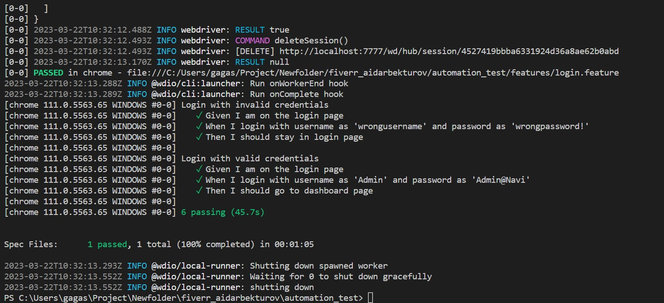

## 8. Test Schedule

### 8.1 Day 1

* Set up environment for testing (Windows 11, NodeJS, Google Chrome Browser)
* Prepare the test
* Execute the automation test

### 8.2 Day 2

* Compile the test execution report
* Review the testing deliverable with relevant stakeholder
* Wrap Up the testing activites

## 9. Approval

I have reviewed the LOGIN-CLIENT-001 test plan and find that it meets the test objectives and requirements for the login page and client page of the software application

I approve the LOGIN-CLIENT-001 test plan as complete and accurate, and authorize the test team to proceed with the test execution phase.

Signed by : ________

Date : ____________